Self-Care
Self-Care: “The ability to refill & refuel oneself in healthy ways” including “engagement in behaviors that maintain and promote emotional well-being.”

Awareness

- Where does your mind go when you daydream?

- If your mind were a NETFLIX movie, what would it be about?

- If your family or friends were feeling how you are, what would you try to do for them?

Physical Health
Guidelines For Better Sleep

Sleeping well is a habit that you can learn! Small changes can have big effects.
Start today by following these rules:
Take care of your body
- Do not drink caffeine: no tea, coffee, or coca-cola after 4 o’clock
- Do not eat a big or spicy meal late in the evening
- Do not go to bed hungry
- Avoid alcohol as it interferes with sleep
Physical exercise, such as a brisk walk, in the late afternoon can help to make your body tired and help you to sleep. Try to do some exercise every day.
Sleep only at night-time and do not have day-time naps, no matter how tired you feel. Naps keep the problem going by making it harder for you to get to sleep the next night.
Having a regular bedtime routine teaches your body when it’s time to go to sleep.
- Have a soothing drink like camomile tea or a milky drink
- Have a bath, or a routine of washing your face and brushing your teeth
- Go to bed at same time each night
- When in bed think of nice things (e.g. think of 5 nice things that happened that day – they might be big or small, such as a nice conversation, seeing the sunshine, or hearing nice music on the radio)
- Do a relaxed breathing exercise (one hand on stomach the other on your chest, deliberately slow your breathing, breathe deeply in your stomach instead of high in your chest)
- Try and wake up the same time every day, even if this is tiring to begin with
Coping with bad dreams can be difficult. Some people don’t like relaxation before going to sleep, or are scared of letting go. If that is you, try these preparation techniques instead:
- Prepare yourself in case you have bad dreams by thinking of a bad dream then think of a different ending for it. Practice this new ending many times before going to sleep.
- Before going to sleep prepare to re-orient yourself when you wake from a bad dream.
- Remind yourself that you are at home, that you are safe. Imagine your street, buses, local shops.
- Put a damp towel or a bowl of water by the bed to splash your face, place a special object by the bed, such as a photograph, or a small soft toy.
- Practice imagining yourself waking up from a bad dream and reorienting yourself to the present, to safety by splashing your face, touching special object, having a bottle of rose or lavender essential oil to sniff, going to window to see surroundings.
- When you wake up from a bad dream- move your body if you can and reorient yourself immediately (touching an object, wetting face, going to the window, talk to yourself in a reassuring way)
Make your bedroom a pleasant place to be
- Get a nightlight
- Keep it clean and tidy
- Introduce pleasant smells such as a drop of lavender oil onto the pillow
- Get extra pillows
- Make sure that your home is safe e.g. doors locked, windows closed.
REMEMBER: Bed is for sleeping, so if you cannot sleep after 30 minutes, get up and do another activity elsewhere such as reading or listening to music (try and avoid TV as it can wake you up). After 15 minutes return to bed and try to sleep again. If you still can’t sleep after 30 minutes get up again. Repeat this routine as many times as necessary and only use your bed for sleeping in.
PSYCHOLOGYTools LS |  | http://psychology.tools

I paid you how much for you to tell me that I need to breath!
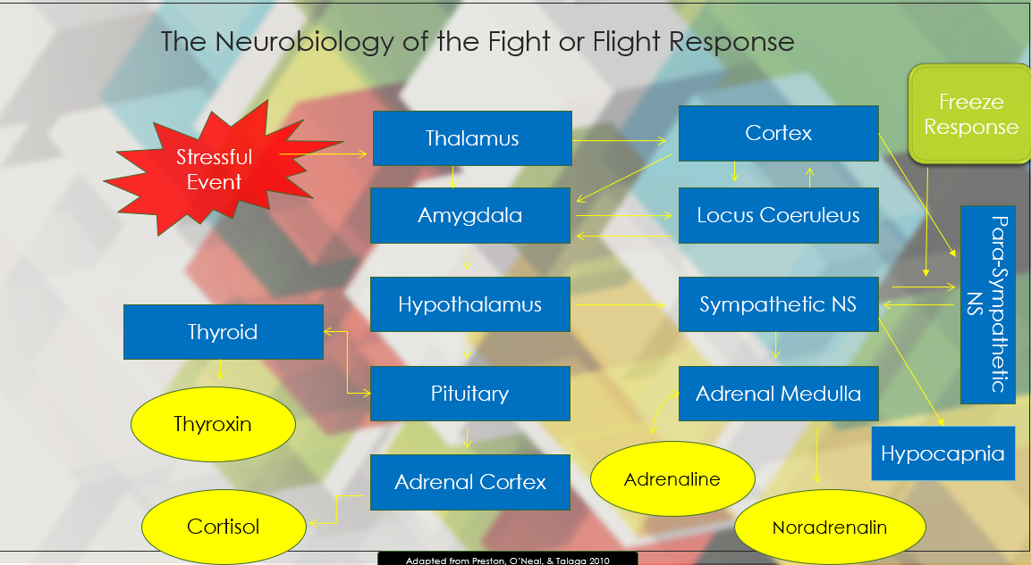
______________________________________________
______________________________________________
______________________________________________
______________________________________________
_______________________________________________
_______________________________________________
_______________________________________________
_______________________________________________
_______________________________________________
_______________________________________________

Adaptation

Pleasure Principle:

Reality Principle:

Moral Principle:

Unhealthy
Violates Reality
Violates Boundaries
Causes significant problems
Healthy
Doesn’t violate reality
Doesn’t violate boundaries.
Will not lead to future problems.
Borderline
Some reality violations
Some boundary violations
May cause some future problems

Rationalization
“It’s only one mistake; I’ll do better next time.”
“How could I get this done with all the other stuff I need to do.”
“I’m not doing it because there’s no way to get all this done.”
“My supervisor’s stupidity caused this problem.”

Regression
Taking a moment to cry it out
Having to walk away so you don’t blow up
Throwing a fit
Getting into a fight
Withdrawal
Taking a break to rejuvenate
Procrastination / Avoidance
Ghosting
Alcohol/Drugs
Psychotic Break

Sublimation

Being stressed and focusing your energy on resolving the problem in a healthy way.

Rehearsal
Thinking through how to do it better next time.
Running through the conflict in your head repeatedly.
Not being able to function because the problem keeps running through your head.
Displacement
Being in a grumpy mood, even towards others.
Being grumpy and blaming others not even involved.
Getting mad at work, then at home it’s taken out on the kids, cat’s, dog, goldfish…

Automatic Thoughts: The thoughts that automatically emerge based upon our experiences and expectations. These are also the primary source for the Beliefs in the model below.
Basic Cognitive Behavioral Model
Thought Tendencies (aka Cognitive Distortions): This is how we tend to think or the lens in which we see the world. For example, the pessimist, optimist, catastrophic thinker, personalizer, black and white thinker, etc. These stem from our schema (experiences) and influence our Automatic Thoughts.
Schema: Our core understanding of ourselves, others and the world around us. It is the accumulation of experiences throughout our life that form how we think about things. It has a significant influence upon our Thought Tendencies and Automatic Thoughts. This is the most difficult to change, but essential if one is to feel better.
Consequence can become its own activating event

Activating Event or antecedent Belief about event Consequence of belief
Thought
Emotional
Behavioral
Biological

I’m going to be fired
Fear
Withdrawal
Panic

- Upcoming deadline 1. “There’s no way”

2. Panic 2. I’ll be homeless
Thought:
Emotion:
Behavior:
Biological:
The downward spiral

Train yourself: You must learn to create at least two other realistic possibilities outside of the worst-case scenario.

Dispute the Belief Experiment with new belief Feelings (consequences change accordingly)

Thought
Emotion
Behavior
Biological
Practice the new belief
Alternative Belief One:

If the new belief is accurate and helps you feel better, why not use that one?

________________________________________________________________________________________________________________________________________________________________________________________________________________________________________________________________________________________________________________________________________________________________________________________________________________________________________________________________________________________________________________________________________________________________________________________________________________________________________________________________________________________________________________________________________________________________________________________________________________________________________________________________________________________________________________________________________________________________________________
________________________________________________________________________________________________________________________________________________________________________________________________________________________________________________________________________________________________________________________________________________________________________________________________________________________________________________________________________________________

Attributional Beliefs Leading to Burnout & Hopelessness

___________________________________________________
___________________________________________________
___________________________________________________
___________________________________________________
___________________________________________________
___________________________________________________
___________________________________________________

Social Support

